Doc Writer: Kamakshi Murali Doc Date: DEC 12, 2014.

Application or System Name

POST Cancel Rebill EMMA (BL_INT_POST_002)

General Overview

Business Requirements:

A new interface will be developed where ESB will pick up the Stale Data Export from the IEE file share and upload the contents of the file into SAP in the form of a web service call. The Stale Data export file would contain data of the interval edited in IEE after the billing determinant has been run for the periods edited. An EMMA case would be created with the details of the intervals edited to be worked upon by the Customer Billing team.

An interface will be developed to pick up the Stale Data Export files generated from IEE and process them in SAP. Emma cases will be generated with the changed interval values.

Technical Design:
REPORT: ZBL_INTERVAL_CHANGE_BPEMCREATE.

- Once the user executes the report two options are provided to the user on the selection screen.
a) Create EMMA Case.
b) Test Run.

- If the user selects Create EMMA Case option then the report would pick all the entries from the table ZTBL_DEM_VAL_CHG which are not processed i.e. it would pick all the files for which the value of the field ZPROC of the table is not equal to ‘X’.

- If any record is fetched from the table ZTBL_DEM_VAL_CHG then
It will fetch the installations based on the respective MDUS request id from the table EMDUSDRQHEAD, as the installations will be passed as the object key while creating the EMMA case.

- If the installations are found then the respective billing document number is fetched from the table ERCH based on the Contract.

- Once all the required Data is fetched then EMMA_MESSAGE will be created for those records through the method WRITE_EMMA_MESSAGE of the class ZCL_CS_AMI_UTILITY and

the field ZPROC of the table ZTBL_DEM_VAL_CHG will be updated to “X” which signifies that these records are processed.

- If EMMA Cases Check box and the TESt RUN checkbox
Option is selected then only the log messages are displayed using ALV and EMMA case will not be created and the table ZTBL_DEM_VAL_CHG also will not be updated.

- If create EMMA Cases Check box in the selection screen and execute the report. Emma case should be created and the processed flag should be updated in the table ZTBL_DEM_VAL_CHG.

- Based on the TVARVC values the old entries from the table ZTBL_DEM_VAL_CHG get deleted automatically on a periodic basis.

System Diagram
☐ Screen that’s presented to user
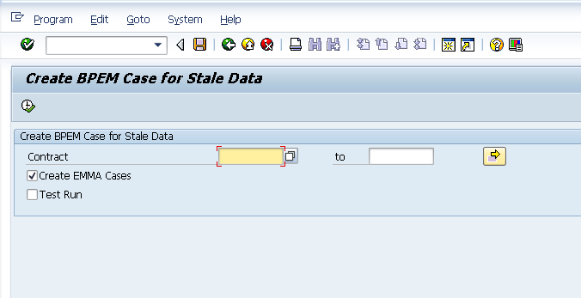

Technical Parts Inventory

-------Name------- | ----Description---- | -----Location----- | ----Environment---
ZBL_INTERVAL_CHANGE_BPEMCREATE | Program |  | E2D
ZCL_CS_AMI_UTILITY/ WRITE_EMMA_MESSAGE | Class/Method |  | E2D
ZTBL_DEM_VAL_CHG | Table |  | E2D
EMDUSDRQHEAD | Table |  | E2D
ERCH | Table |  | E2D

Dependent Parts Inventory
-------Name------- | ----Description--- | -----Location----- | ----Environment---

Security Roles and AD Group Needed to Run App

